DBMS LAB – 6
ADDITIONAL QUERIES ON EMPLOYEE DATABASE:
1.List employees with their department name & location
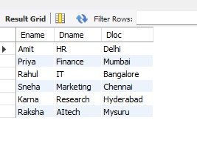
2. Employees who are not assigned to any project
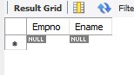
Project-wise headcount
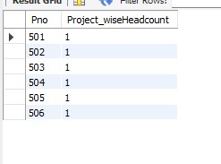
3. Department-wise average & max salary
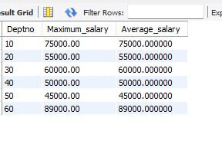
4. Total incentives earned by each employee (lifetime)
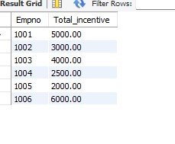
5. Employees working on a given project (project name :Alpha Project)
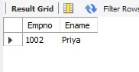
6. Departments with no employees
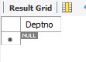
7. Managers and their direct report counts (MGR_NO references EMPNO)
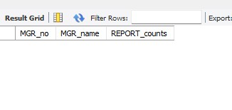
8. Employees assigned to more than one project
